Water footprints

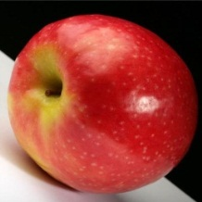 | Global average water footprint: 70 litres for one apple.  We assume here a hundred-grams apple. One glass of apple juice (200 ml) costs about 190 litres of water.
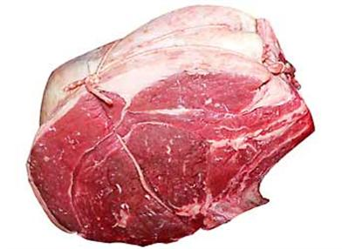 | Global average water footprint: 15, 500 litres of water per kg of beef.  In an industrial beef production system, it takes in average three years before the animal is slaughtered to produce about 200 kg of boneless beef.  The animal consumes nearly 1300 kg of grains (wheat, oats, barley, corn, dry peas, soybean meal and other small grains),  7200 kg of roughages (pasture, dry hay, silage and other roughages), 24 cubic meter of water for drinking and 7 cubic meter of water for servicing.  This means that to produce one kilogram of boneless beef, we use about 6.5 kg of grain, 36 kg of roughages, and 155 litres of water (only for drinking and servicing).  Producing the volume of feed requires about 15300 litres of water in average.
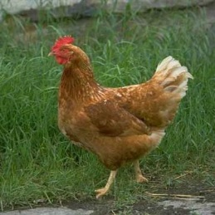 | Global average water footprint: 3900 litres for 1 kg of chicken meat.  In an industrial chicken farming system, it takes 10 weeks on average before the chicken is slaughtered.  It will produce 1.7 kg of chicken meat.  A chicken consumes about 3.3 kg of grains (mainly soybean meal, wheat, corn, canola meal and mill screen)  and 30 litres of water for drinking and servicing the farmhouse.  This means that to produce one kilogram of chicken meat, we use about 2 kg of grains and 20 litres of drinking and servicing water.  Producing 2 kg of feed of this composition takes about 3.9 m3 of water on average.
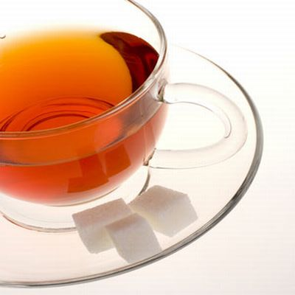 | Global average water footprint: 30 litres of water for one cup of tea.  To produce 1 kg of fresh tealeaves we require 2400 litres of water.  One kg of fresh tealeaves gives 0.26 kg of made tea, so that 1 kg of made tea (black tea as we buy it in the shop) costs 9200 litres of water.  For a standard cup of tea we require 3 gram of black tea, so that a cup of tea requires 30 litres of water.  A standard cup of tea (250 ml) thus requires 120 equal-sized cups of water.  All together, the world population requires about 30 billion cubic metres of water per year in order to be able to drink tea.  This is equivalent to 4 times the annual Meuse runoff.  Most tea is produced in rain-fed areas; only a minor fraction of the world tea production comes from areas with supplementary irrigation (a practice sometimes applied at lower altitudes).  The water needs for post-harvest processing can be neglected if compared to the water needs for growing the tea plant.  The water footprint of tea thus mainly refers to rainwater use.
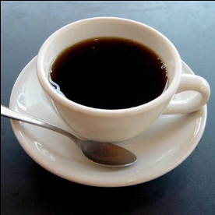 | Global average water footprint: 140 litres for 1 cup of coffee.  It costs about 21000 litres of water to produce 1 kg of roasted coffee. For a standard cup of coffee we require 7 gram of roasted coffee, so that a cup of coffee costs 140 litres of water. Assuming that a standard cup of coffee is 125 ml, we thus need more than 1100 drops of water for producing one drop of coffee. Drinking tea instead of coffee would save a lot of water. For a standard cup of tea of 250 ml we require 30 litres of water.  The world population requires about 120 billion cubic metres of water per year in order to be able to drink coffee. This is equivalent to 1.5 times the annual Rhine runoff and constitutes 2 % of the global water use for crop production. International trade in coffee products is responsible for 80 billion cubic meters of virtual water exports, which is about 6% of the international virtual water flows in the world. Among all the crop and livestock products coffee stands at the top position in the list of global virtual water flows.
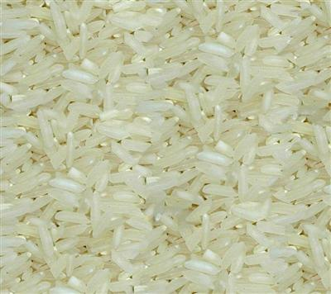 | Global average water footprint: 3400 litres for 1 kg of rice.  The rice fields in the world consume about 1350 billion cubic meters of water annually, which is 21 % of the global water use for crop production.  Paddy rice (the rice as harvested from the field) has consumed 2300 litres of water per kg.  One kg of paddy rice produces 0.67 kg of milled rice on average.  In the shop we buy milled rice in the form of white rice or broken rice.  In this form, rice costs 3400 litres of water per kg.  This total volume of water refers to a mix of rainwater (‘green water’) and irrigation water (‘blue water’).  The ratio of blue to green water depends on the production circumstances at the place of growth.  In China for example, most rice is irrigated, which means a relatively high ratio blue/green, while in India irrigation of rice is much less common.  International rice trade brings along large international virtual water flows.  The sum of virtual water flows between countries related to rice trade is about 75 billion cubic meters of virtual water per year.
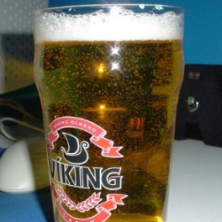 | Global average water footprint: 75 litres of water for one glass of beer.  One glass contains about 250 ml of beer.  Most of the water behind the beer is for producing the barley.
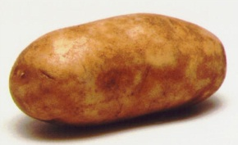 | Global average water footprint: 900 litres for 1 kg of potato flakes  A bag of potato crisps (200 gr) has a water footprint of 185 litres.
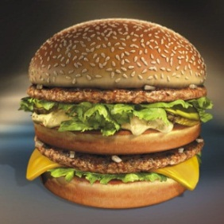 | Global average water footprint: 2400 litres of water for one hamburger!  Most of the water is needed for producing the beef contained in the hamburger. In our hamburger we assumed there is about 150 gram of beef
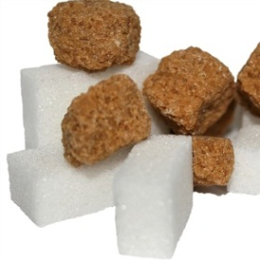 | Global average water footprint: 1500 litres of water for 1 kg of cane sugar.  Sugar can be produced from different crops, such as sugar cane or sugar beet. We consider here the case of sugar cane. It takes about 175 litres of water to produce 1 kg of sugar cane. About 11% of the sugar cane is sugar, so that 1 kg of sugar cane gives 0.11 kg of sugar. Hence, for 1 kg of refined sugar we did require about 1500 litres of water.  Sugar cane consumes about 220 billion cubic meters of water annually, which is 3.4 % of the global water use for crop production.
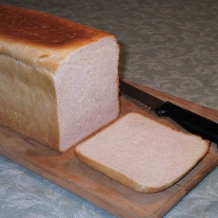 | Global average water footprint: 40 litres of water for one slice of wheat bread.  Producing wheat costs 1300 litres of water per kg (global average).  One slice of bread has a weight of about 30 gram, which implies a water footprint of 40 litres.  If the bread is consumed together with 1 slice of cheese (10g), then it all together costs 90 litres of water.
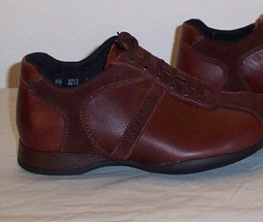 | Global average water footprint: 16600 litres for 1 kg of leather.  The water footprint of leather highly depends upon the kind of animal it is produced from.  For the tanned leather from a bovine cow it costs about 16000 cubic meters of water per ton of leather.  Besides hide and skin an animal also produces other products such as milk, meat and bones etc.  The volume of water consumed during the entire life span of the cow is thus attributed to these products based on their relative market values and quantity obtained per animal.
Global average water footprint: 10 litres of water for one A4-sheet of paper.

We assume here eighty-grams paper (80g/m2). Further we assume that the paper is produced from wood. Consider a production forest with an annual evapotranspiration of 600 mm/yr, which is equal to 6000 m3/ha/yr. Suppose that the forest yields 10 m3 of wood per hectare per year. Finally, account for the fact that 1 m3 of wood gives 0.3 ton of paper. This means that the (green) water footprint of paper is 2000 m3/ton (= 2000 litres/kg). Since 1 A4-sheet of paper has a weight of 0.005 kg, this means that 1 A4 has a green water footprint of 10 litres.

On top of these 10 litres come the blue and grey water footprints related to consumption and pollution of water during the paper manufacturing process. The blue water footprint of paper is very small: about 6 m3/ton, which means 0.03 litre for one A4-sheet of paper. This figure mostly refers to evaporation of water used in the milling process; a minor part refers to water retained in process residuals (source: NCASI, 2009). The effluents of paper mills contribute to a grey water footprint when not properly treated before disposal. The figure of 10 litres for one A4-sheet of paper does not include a grey water footprint component, which holds for cases where wasteflows are treated up to standard.

The figure of 10 litres for one A4-sheet of paper obviously varies from case to case, depending on the source of the wood. Particularly, forest evapotranspiration and wood yield vary from forest to forest. The number will likely fall in a range of 2 to 30 litres of water per A4-sheet.
Global average water footprint: 2700 litres for 1 cotton shirt.

In order to get 1 kg of final cotton textile, one requires 11,000 litres of water (as a global average). Thus, when we have a shirt with a weight of 250 gram, this shirt costs 2700 litres. Of this total water volume, 45% is irrigation water consumed (evaporated) by the cotton plant; 41% is rainwater evaporated from the cotton field during the growing period; and 14% is water required to dilute the wastewater flows that result from the use of fertilisers in the field and the use of chemicals in the textile industry.

Globally, the annual cotton production evaporates 210 billion cubic meters of water and pollutes 50 billion cubic meters of water. This is 3.5 % of the global water use for crop production.
A cotton shirt is made from cotton fabric, which is made from combed or carded cotton, which is derived from cotton lint, which comes from seed cotton, which is harvested from the cotton field. Indeed, before the final cotton textile reaches to the hands of a consumer it passes through a number of intermediate processes and products. First the seed cotton is processed into lint (we get only 350 kg of lint out of 1000 kg of seed cotton), then after carding, spinning and weaving we get grey fabric (1000 kg of lint produces only 900 kg of grey fabric), then it goes to the wet processing (bleaching and dying) and finishes as final printed cotton textile. It requires about 30 m3 per ton for bleaching, 140 m3 per ton for dying and 190 m3 per ton for printing. The average water footprint of printed cotton (for example a pair of jeans weighing 1 kilogram) is 11000 litres per kilogram.

Water use for cotton production can have major impacts on the environment. Particularly intensive irrigation schemes can have disastrous effects, as shown for example in the case of Uzbekistan and the desiccation of the Aral Sea.
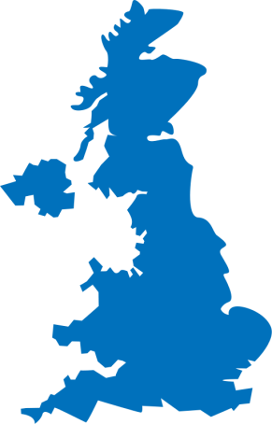 | Average water footprint of United Kingdom: 1258 m³/yr per capita  Part of footprint falling outside of the country: 75.2 %  Global average water footprint (for comparison): 1385 m³/yr per capita

